**Good Website Design Vs Bad Website Design**

1. **Websites under discussion:**
   1. Hopscotch [ <https://www.ilovehopscotch.com/new-in.html> ]
   2. MinnieMinors [ <https://www.minnieminors.com/pages/minnie-minors> ]
2. **Intention:**
   1. To demonstrate the difference between good website design and bad website design with respect to Human Computer Interaction. This is just an educationally intended documentation.
3. **Images:**
   1. 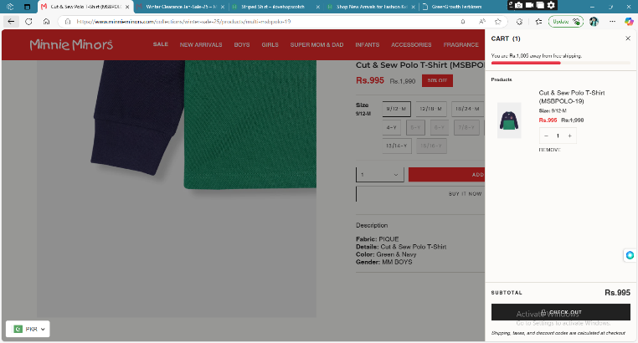MinnieMinors

* 1. 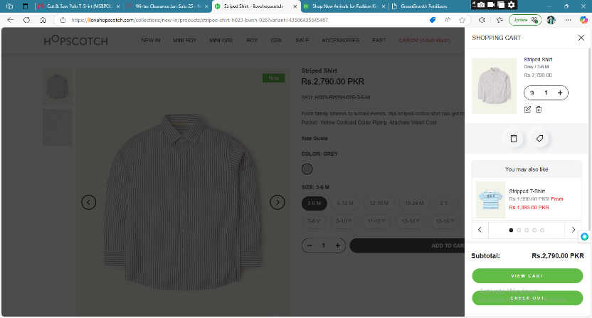HopsCotch

1. **Difference:**

|  |  |
| --- | --- |
| Minnie Minors | Hopscotch |
| No Zoom effect on the main page. | Zoom product image on hover, on main page (hence, reducing extra navigations). |
| Images Viewed by scrolling page vertically. | Images viewed by scrolling a carousel horizontally. |
| Comprehensive Product description. | Description seems more of the advertisement. |
| It offers buy now as well as Add to card. | It only offers Add to card from the product page |
| Very Basic layout design of Add to Cart Tray. | Clean layout and offers more options at the Add to Cart Tray. |
| No suggestions on the Add to Cart tray | Suggests similar products on the Add to Cart tray |

1. **Conclusion:**

The Hopscotch website seems to be more well designed than MinnieMinors’, because:

* It offers good UX.
* Depreciate extra navigations.
* Offers features where they are more required.
* The color pallet that is used seems more professional.
* Does not use extra animations, resulting in lighter website.